22.64: (See Problem 22.63 with 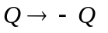for terms associated with right sphere)
a) 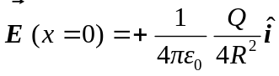
b)
c) 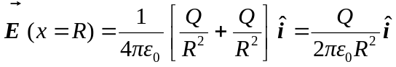
d) 